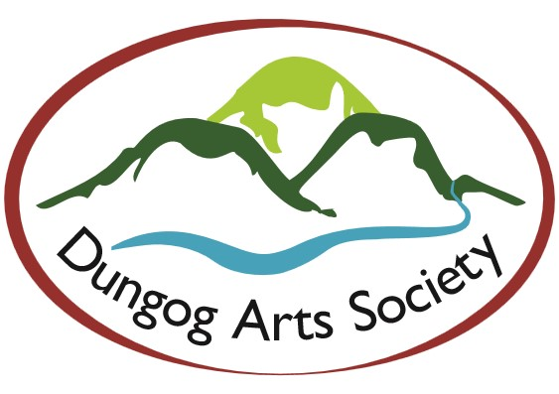

MISSION STATEMENT

_____________________________________

Our organisation aims to: -

- Provide a focal point for the fostering of creative activities for all members of the community, and to further develop artistic awareness of both visual and performing arts.

- Promote local talent by providing a creative base and tourist facility of local significance.

- Engage in activities intended to develop the practice of arts and crafts in the community.

- To be the most progressive Arts Society in the Lower Hunter Region through participation, promotion, support and management.



DUNGOG ARTS SOCIETY INC.

MEMBERSHIP APPLICATION
__________________________

If you are interested in either visual or performing arts
(music, drawing, painting, craft, etc)
we would like to invite you to join our society.

Activities which you may enjoy include –

Newsletters - notifying members of items of interest and
forthcoming events, posted or e-mailed to members
each month.

Workshops &
Demonstrations - are held regularly on a variety of subjects.

Excursions - by bus or car/share, are arranged regularly to view

various galleries and exhibitions.

Art
Exhibitions - offer members the opportunity to exhibit their work.
Our own open competitive exhibition is held annually.
Invitations for members to show their work in other exhibitions are frequently received

Meetings - welcome all members who would like to take an active
part in the organizing of our Society.

Volunteers - Our activities, as outlined above, cannot occur without help from volunteers. Assistance from our members is always greatly appreciated.

For further information please contact –

President Toby Solomon 0428 630214
Vice President Cynthia Denning 0422 847599
Secretary Greg Mudie 0407 953928
Assistant Secretary Donna Woodlands 0421 704449
Treasurer Ruth Dircks 4992 3008
Membership & Marilyn Rudak 0416 435651
Minutes Secretary
Newsletter

Curator Cynthia Denning 0422 847599

Meetings
held 1st Thursday of each month
at 5.30pm
Artists Workshop.
266 Dowling St. Dungog.

The annual fee is $50.00 for a single member
$75.00 for a family.
$25 for a supporting member - to receive the Newsletter only.

We look forward to welcoming you to our Society.

Email – dungogartssociety@gmail.com
Website – dungogartssociety.com.au

MEMBERSHIP APPLICATION
Type of Membership (Please tick)
New Renewal Single Family Supporting

Please print

SURNAME ………………………………………………………………………………………….................
GIVEN NAME …………………………………………………………...……………………………………………
ADDRESS..………………………………………………………..……………………………………………………
Post Code………………………
Telephone No. …………………………………………………………Fax No.…………………………...
E-Mail Address …………………………………………………….………………………………………..
NAMES OF OTHERS IN FAMILY (if Family Membership is required)
……………………………………………………………………………………………………………………………………………………
PARTICULAR INTERESTS ..…………………………………………………………………………………
…………………………………………………………………………….…………………………………………………………………….
I would prefer to receive my Newsletter by post e-mail
Enclosed please find my annual fee in cash cheque
Direct Debit to The Mutual Bank BSB 646000 A/C 100073110
for the amount of $….………………….….

Please cut off this side of your application and return with your fee to
Membership Secretary,
PO Box 48 Dungog 2420
Or if Direct Debit by email
Your monthly newsletter will be forwarded
to you on receipt of this application
Fees are due from July each year.
_______________________________________________________
Office Use Only
Member No……………………….. . Receipt No…………………………. Date ……………….…….
List Email Card Sent

